Claude Code Command Reference
Slash commands, shortcuts, flags and the quick-start launch commands

29  slash commands | 7  command groups | 8  keyboard shortcuts | 6  input modes & flags

About this document
A quick-reference sheet of the Claude Code commands, shortcuts and flags listed in the course notes. Use it as a cheat sheet while working in the terminal.
How to use it: the flowchart on the next page shows the whole toolkit at a glance. Section numbers in the flowchart match the section numbers below, so you can jump from the picture straight to the detailed table.
Source: Extracted from the course notes “FAANG level code with Claude Code” (.md file).

Please note
Commands are reproduced as written in the source notes. Claude Code changes over time, so run /help inside your installed version to confirm the commands, flags and option values available to you.

Contents
• Command map (flowchart overview) (page 2)
• 1 Start Claude Code, and launch flags
• 2–8 Slash commands, in seven groups
• Keyboard shortcuts and quick input modes
• Extra features and running the Streamlit demo app
• Appendix: detailed command map (flowchart) (last page)

Command map (overview)
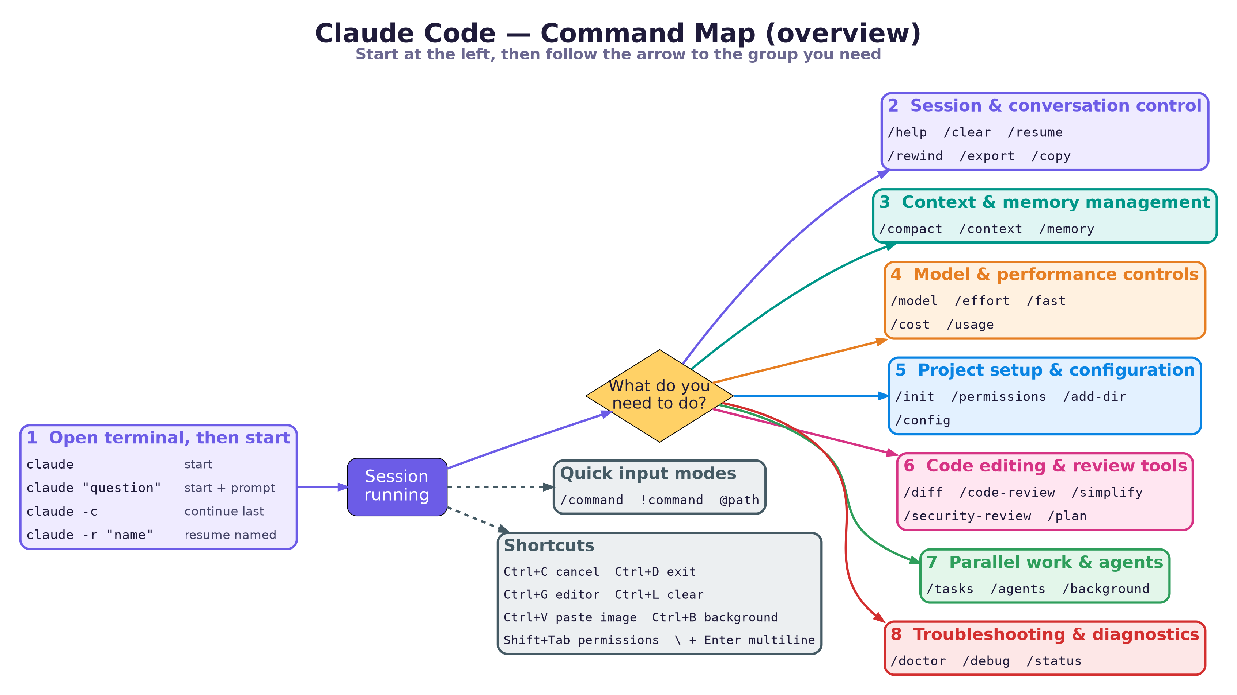

1 Start Claude Code
Run these in your terminal, inside your project folder.
Command | What it does
claude | Start an interactive session
claude "your question" | Start with an initial prompt
claude -c | Continue your most recent conversation
claude -r "session-name" | Resume a specific session

Useful launch flags
Flag | What it does
--model opus/sonnet/haiku | Choose AI model
--permission-mode plan/auto/ask | Set permission level
--tools "Bash,Read,Edit" | Restrict available tools

Key slash commands
Type a slash command at the Claude Code prompt. They are organised into seven groups (2 to 8, matching the flowchart).

2 Session & conversation control
Command | What it does
/help | Get help with Claude Code
/clear | Clear conversation history
/resume | Resume previous sessions
/rewind | Undo changes to code or conversation
/export | Export conversation
/copy | Copy the last response to clipboard

3 Context & memory management
Command | What it does
/compact | Summarize conversation to free context
/context | Visualize what’s in the context window
/memory | View or edit CLAUDE.md project memory

4 Model & performance controls
Command | What it does
/model | Switch AI models (Haiku / Sonnet / Opus)
/effort | Adjust reasoning depth (low → max)
/fast | Toggle fast output mode
/cost , /usage | View token usage and limits

Choosing a model with /model
Haiku — Fastest, lightest
Sonnet — Balanced
Opus — Heavy reasoning specialist

5 Project setup & configuration
Command | What it does
/init | Generate a starter CLAUDE.md
/permissions | Manage tool permissions
/add-dir | Add another directory for Claude to access
/config | Open settings (theme, defaults, editor mode)

6 Code editing & review tools
Command | What it does
/diff | View uncommitted changes
/code-review | Review code for bugs or improvements
/simplify | Cleanup-only review for efficiency
/security-review | Scan for security issues
/plan | Enter read-only plan mode before making changes

Tip
/plan is read-only: Claude proposes changes without making them. Review the plan first, then let it build.

7 Parallel work & agents
Command | What it does
/tasks | View background tasks
/agents | Manage subagents
/background | Run session as a background agent

8 Troubleshooting & diagnostics
Command | What it does
/doctor | Diagnose installation and environment problems
/debug | Investigate runtime issues
/status | Show model, version, and working directory info

Critical keyboard shortcuts
Shortcut | What it does
Ctrl + C | Cancel current operation
Ctrl + D | Exit Claude Code
Ctrl + G | Open in text editor
Ctrl + L | Clear screen
Ctrl + V | Paste images from clipboard
Ctrl + B | Move tasks to background
Shift + Tab , Alt + M | Toggle permission modes
\ + Enter | Start multiline input

Quick input modes
Type | What it does
/command | Run slash commands
!command | Run bash commands directly
@path | File path autocomplete

Extra features
Try | What it does
/help | Run inside Claude Code for help
/ | Type a slash to see all available commands
? | Press to see keyboard shortcuts

Running the Streamlit demo app
From the same notes: how to launch the onboarding app (and FocusDesk) in the browser.
Command | When to use it
streamlit run app.py | Simplest command to launch the app
python -m streamlit run app.py | Use when you hit environment or path issues

Appendix: detailed command map
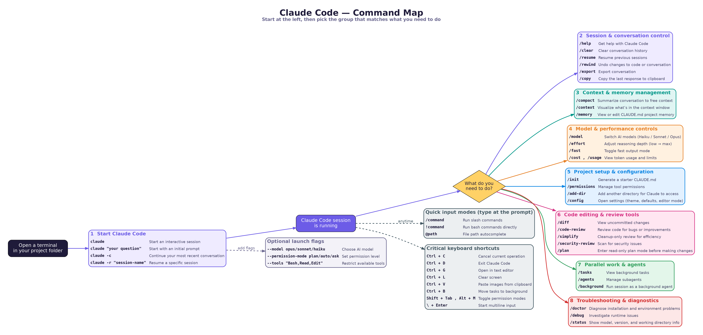
The same image is supplied separately as commands_flowchart.png for zooming in.

